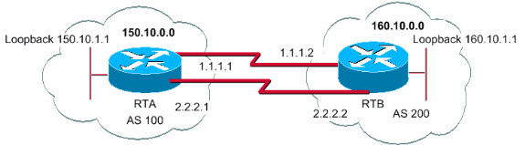

**eBGP с несколькими переходами (распределение нагрузки)**

RTA#

int loopback 0

ip address 150.10.1.1 255.255.255.0

router bgp 100

neighbor 160.10.1.1 remote-as 200

neighbor 160.10.1.1 ebgp-multihop

neighbor 160.10.1.1 update-source loopback 0

network 150.10.0.0

ip route 160.10.0.0 255.255.0.0 1.1.1.2

ip route 160.10.0.0 255.255.0.0 2.2.2.2

RTB#

int loopback 0

ip address 160.10.1.1 255.255.255.0

router bgp 200

neighbor 150.10.1.1 remote-as 100

neighbor 150.10.1.1 update-source loopback 0

neighbor 150.10.1.1 ebgp-multihop

network 160.10.0.0

ip route 150.10.0.0 255.255.0.0 1.1.1.1

ip route 150.10.0.0 255.255.0.0 2.2.2.1